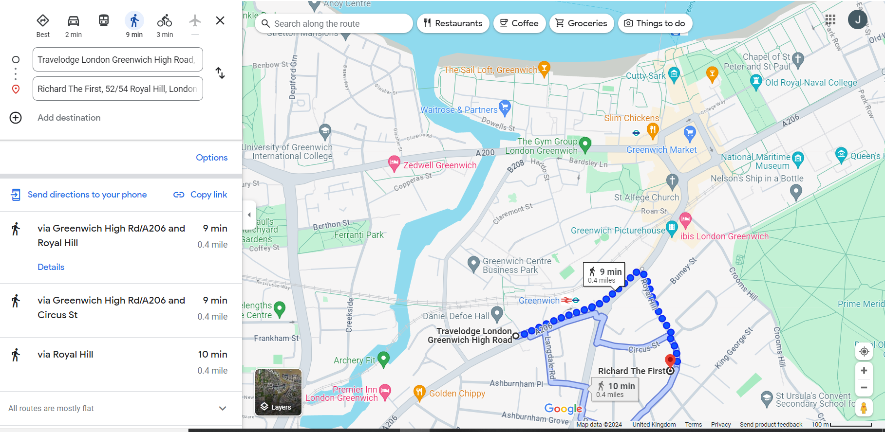

The Richard the First pub is 52/54 Royal Hill, as shown above. A space in the garden has been reserved on Thursday 27th June from 6.30 p.m. onwards. Food and drink can be ordered individually. The Colloquium on Friday 28th June will be in room QA 010 of the Queen Anne Court building of the Royal Naval College, shown in the top right hand corner of the map above. Room QA 010 is on the ground floor and has a short flight of steps. Please let the convenor Justin Stephens know in advance if you require any mobility assistance.

